Nepal College of Information Technology
Unit Test
Spring 2010
Program : BE Time : 2 hrs
Semester : Spring (IV) FM : 70
Subject : Engineering Math-IV PM : 35

- Candidates are requested to give their answer as far as practicable in their own words.
- The figure in the margin indicates the full marks
- Attempt ALL question
1. a) Show that the function f(z) is discontinuous at z=0 if f f f(z)=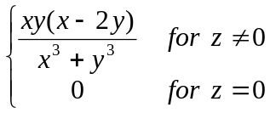 5
b) Define analytic function. Check analyticity of function f(z)= z² 5
c) Express the function f (z)=coshz in the term of u+iv 5
2. a) Show that the function u(x,y)=3x²y+x²-y³-y² is a harmonic function. Find its harmonic conjugate. 8
b) Define Fourier Integral. Show that 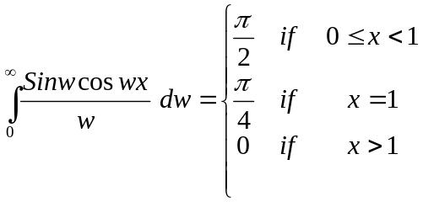 7
3. a) Let f(x) be continuous and absolutely integrable on the x-axis, Let f ′(x) be piecewise continuous on each finite interval and let 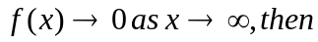
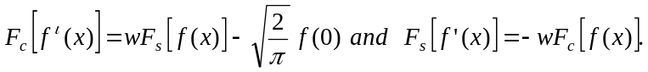 8
b) Find Fourier transform of f(x)=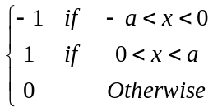 7
4. a) Maximize z= -10x₁+2x₂ subject to x₁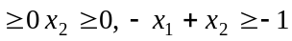
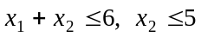 using graphical method. 7
b) Maximize z=150x₁+300x₂ subject to the constraints Using simplex method. 8
5. Attempt any two: 5*2=10
a) Find a solution u(x, y) of equation 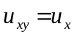
b) Find Fourier cosine transform of f (x) = e^{-x}, x >0.

c) Express in module amplitude form
